**Software Engineering CEN 302**

**Project**

**BINF III C**



**Group members:** Adela Kaçorri, Adela Kondakçiu, Griselda Ramadani, Megi Lala

**Group leader:** Megi Lala

**Roles:** Design the code for the client’s pages, login and registration, create the database- Megi Lala, Adela Kaçorri

Design the code for the worker’s page, where shown their profiles and appointments- Griselda Ramadani, Adela Kondakçiu

**BEAUTY CENTER**

**Identified problem:** Commonly when someone wants to book an appointment at an esthetical center, they either need to direct message them on Social Media or make a phone call. Hundreds of messages or calls can be made during a very short period of time and managing it can be very overwhelming and time consuming for the workers and clients. The client messages may not be opened, deleted by accident, left on read or even someone that has written before someone else may be left without an appointment due to poor management of the schedule. Canceled appointments also appear to be a problem.

**Solution proposed:** Proposing a quicker way for clients to make their appointments through the application according to their preferences. Helping workers manage their time and work.

**Aim:** The aim of our project is to create an application that can simplify the work of the employees and go through the appointments made by the clients in this application. Workers don’t have to keep track of the appointments that clients make everyday through the phone or Social Media, they can just check the schedule shown in the app. On the other hand, clients can decide which time is appropriate for them according to the scheduled calendar of available dates.

**Objectives:**

* Creating a functional application to book appointments
* Registering the clients that want to book an appointment
* Accessing the profile to show the client’s or technicians’ information by logging in their account
* Displaying the available times for each type of service
* Displaying the reservations

**Description of Application:**

The application will consist of the main page where everyone visiting the **Beauty Center** website will see in the homepage a short introduction of what the center offers, alongside with the contact information. In the **Photos** we will display some of the works done by the nails and lash technicians. In the **Register** the clients will have the option to sign up by filling in information such as name, surname, date of birth, email, phone number, username and password. Once registered, they will be able to login and access their profile.

Regarding the client’s **My Profile**, once logged in they can have the possibility to see their profile. It will include their name, last name, date of birth, phone number and email address. The client will have two dedicated pages for the two types of services offered by the center, **Book Lashes** and **Book Nails**. In both of these pages, the client will be able to see a calendar displaying only the current week and 2 upcoming weeks from the current date they are accessing the website. All the past dates which were unreserved will be marked in white as unavailable. Those booked past and upcoming will be marked in red as unavailable. The available dates will be shown in blue color. The client will have the option to click on an available time slot according to their preference and book their appointment for the specific type of service. On **My Reservations** page, they will be able to see all the reserved appointments they have made according to the type of service, ordered from the earliest ones to the latest. After booking and checking the reservations, the client can click on the **Logout** button to log out.

Regarding the technicians, they can login by clicking the N/L Technician Login. Once logged in they can have the possibility to see their profile. The technician’s **My Profile** will display their name, surname, phone number, email address and the type of service they offer in the center. In the **Client’s Reservation** page they will be able to see the current week’s reservations ordered by date from the earliest to the latest. After checking the reservations they can logout by clicking the **Logout** button.

**Development Model:**

The development model that our group has chosen for this project is the plan-driven model.

**Users:**

1. Nail and Lash Technician (N/L Technician)
2. Clients

**User Requirements:**

- The clients will be able to create an account by registering on the website

- The client and technician will have the option to log in to their profile by their username/ email and password

Technician:

-Display technician information on their profile.

-Display on page the appointments that are reserved during the week.

Clients:

-Display the client’s information on their profile.

-Display on page the schedule of each girl in the personnel to book the preferred time by choosing the type of service.

-Display on page the previous, current and future appointments.

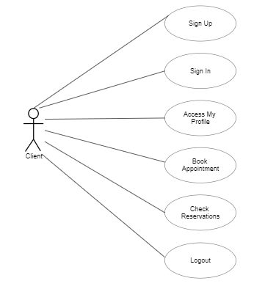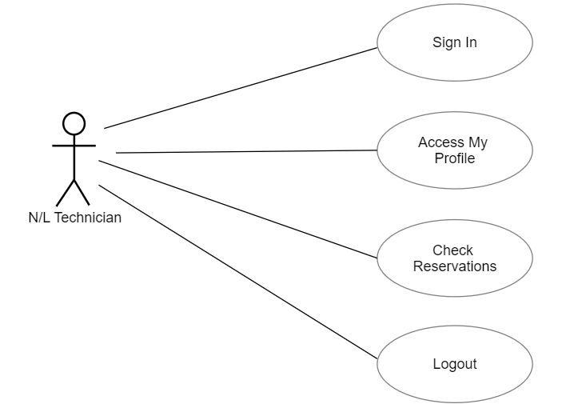

**System Requirements:**

- The system will offer the options of registering for new clients.

-For registration of the clients, the system will require to fill in the data including name, last name, username, date of birth, phone number, email address, password.

-For technician and client login, the system will require the username/email and the password to enter the profile by clicking the specified button.

-For each client, their profile information will be displayed including name, surname, date of birth, phone number and email address.

-For each technician, their profile information will be displayed including name, surname, email address, phone number and type of service they offer.

-For each week the system will generate for each technician a list of appointments specifying the name, last name of client, phone number, date and hour and ordering them from the earliest to latest.

-In the clients page, there will be two buttons to select the type of service they want and after clicking, the available times will be shown.

-The calendar will display 3 weeks in total, including the current week and the 2 upcoming weeks from the current date of accessing the profile in the website.

- The system should save the changes made by the users showing all the appointments available and those which are not.

-The system will show in the calendar past unreserved dates with white color time slots marked as unavailable.

-The system will show in the calendar past, current and upcoming dates which have been reserved with red color time slots marked as unavailable.

-The system will show in the calendar current and upcoming dates which are not reserved yet with blue color time slots and the specific time shown inside the slot.

**Non-functional Requirements:**

-The application should be easy to use.

-The application should be supported by different types of browsers.

-The application should be reliable.

-The application should provide protection of clients’ data.

-The application should be fast and provide the information quickly.

**Application Specification:**

Beauty Center application will be developed using scripting languages such as PHP, HTML, CSS and JavaScript. With the integration of these languages, the application will provide an interactive and responsive user interface. The user interface will be simple and easy to use, which will provide a smooth experience for the clients wanting to book an appointment and see their reservations.

**System Modeling:**

For this part of the project we have decided to approach the application from the interaction perspective, where we will model the interactions between the components of a system.

Therefore, we will use the Interaction model to identify the actors in the system, the component and display component interactions. The two UML diagram types used are Use Case diagram and Sequence diagram as shown below.

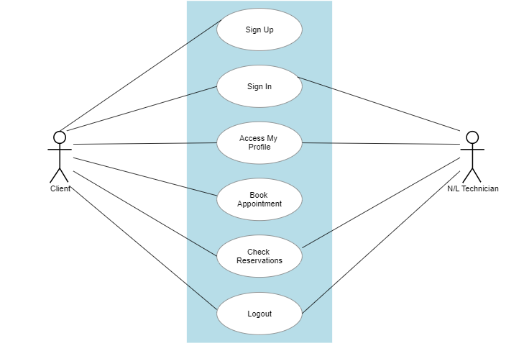

As seen in the Use Case diagram, the two actors in the system are the Client and the N/L Technician. Inside of the container we can clearly see the use cases/ tasks of each actor. The client will be able to sign up, sign in, access my profile, book appointments in the application, check the reservations and log out. Whereas the technician will be able to sign in, access my profile, check the reservations and log out.

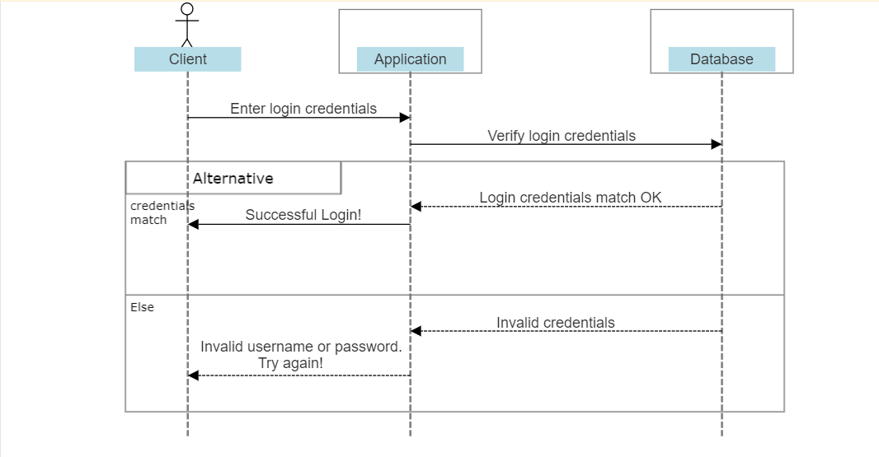

In the Sequence diagram above we have depicted the login procedure in our application and there is included the actor which in this case is the client and the two objects which are the application and the database. The client should be able to enter the login credentials (username and password) in the Client Login page of the application. Then this information will be sent to the database in order to check and verify that first there is someone registered with that username and then if the credentials entered match. If the credentials match that a message will appear to the client “Successful Login!”, otherwise the message “Invalid username or password. Try again!” will be displayed on the screen.

**Design:**

Please find below the design of the BEAUTY CENTER Website.

**Homepage**

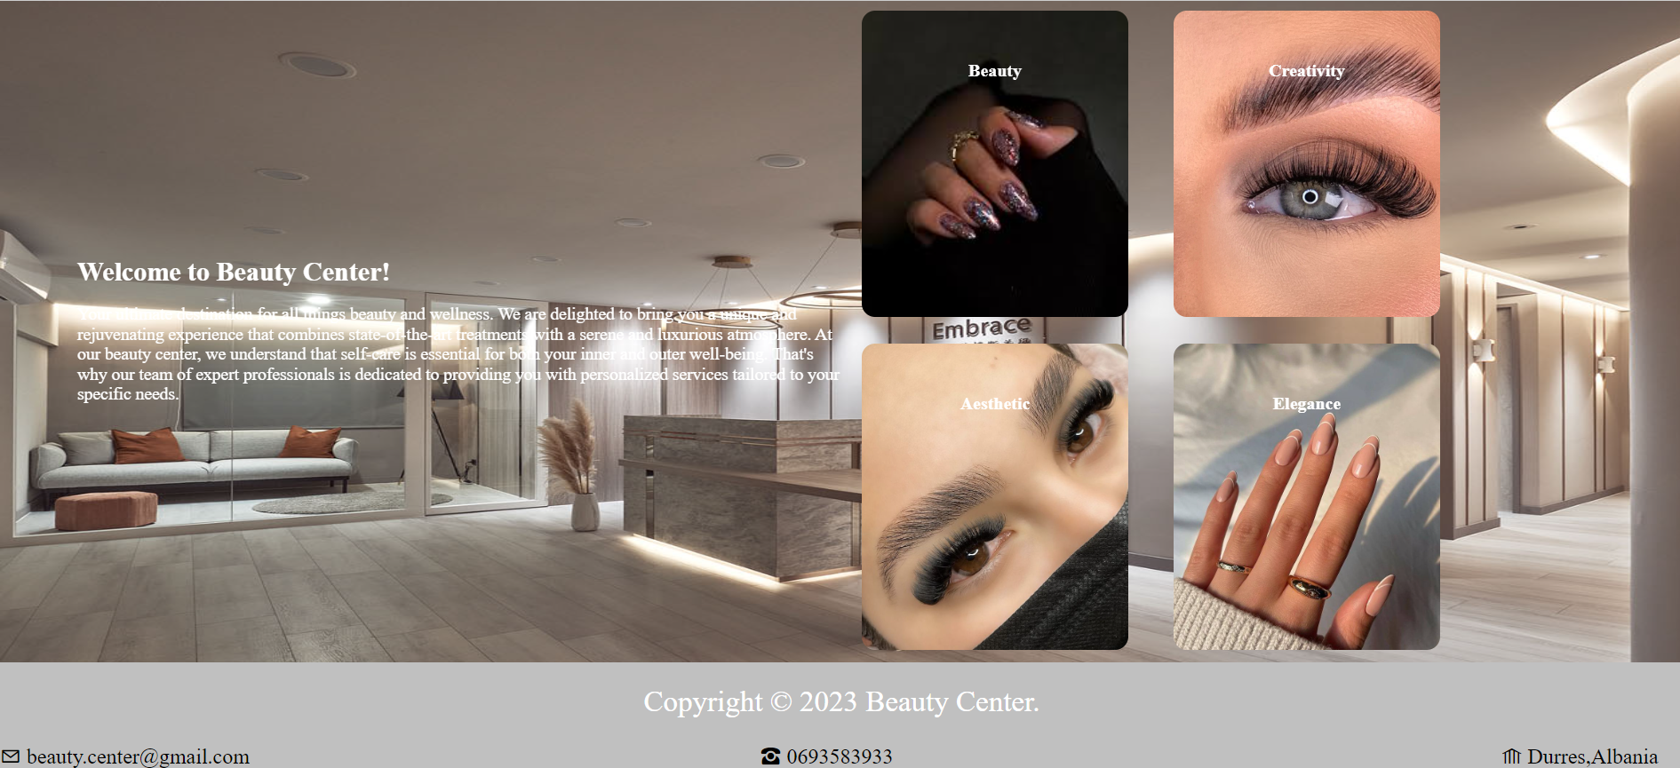

**Photos**

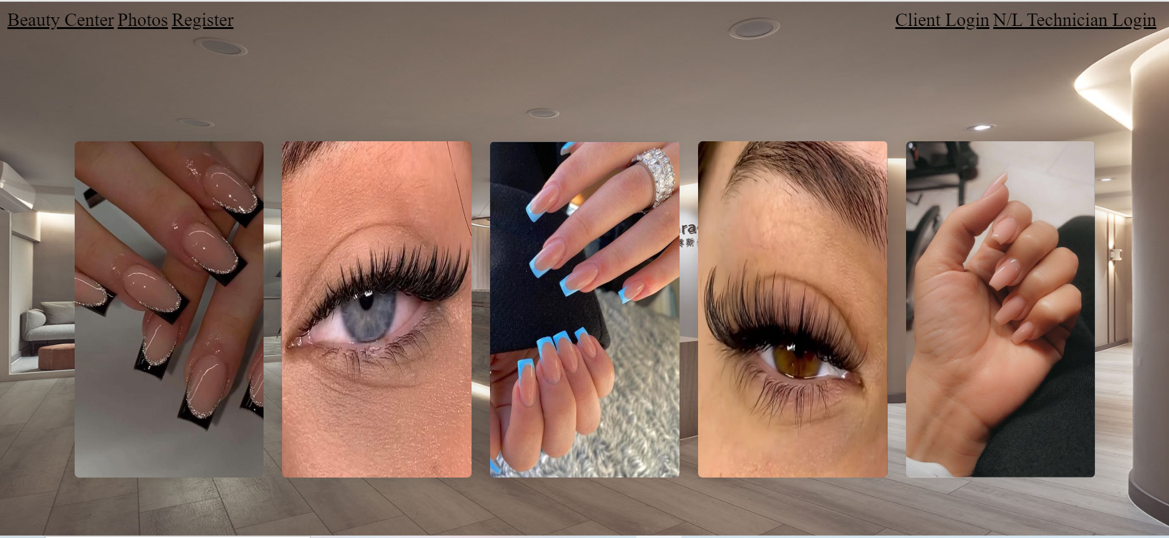

**Register**

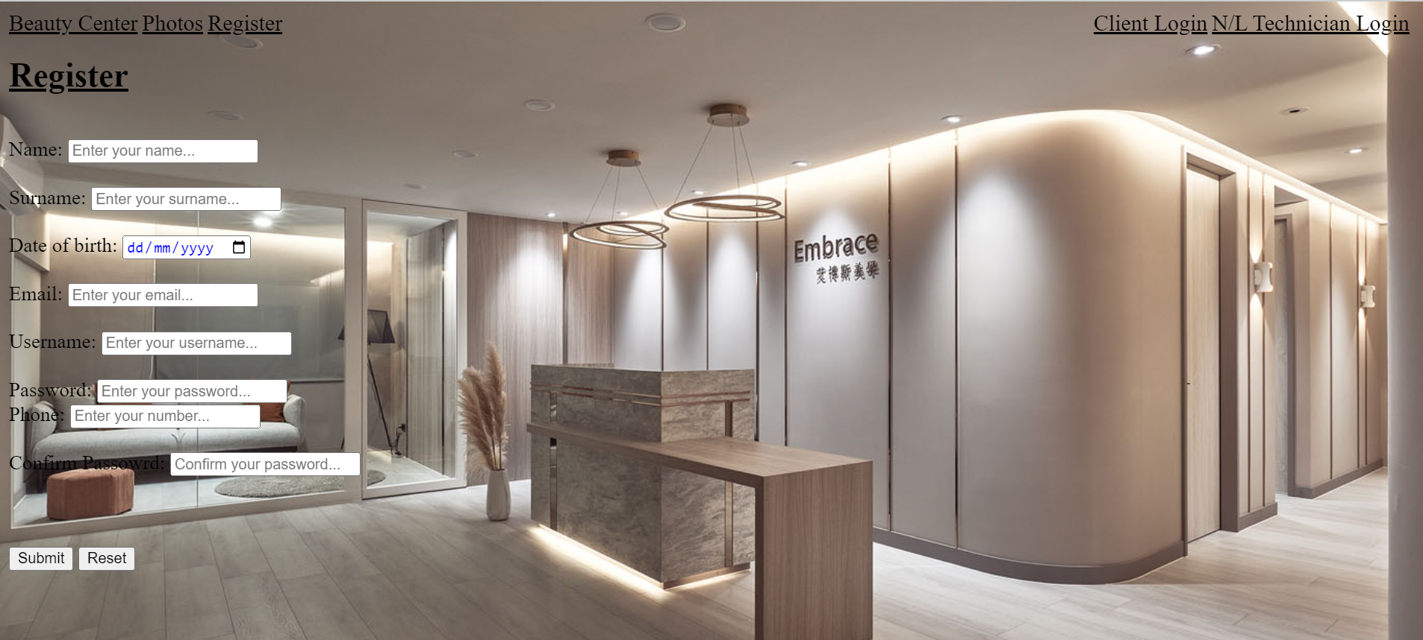

**Login**

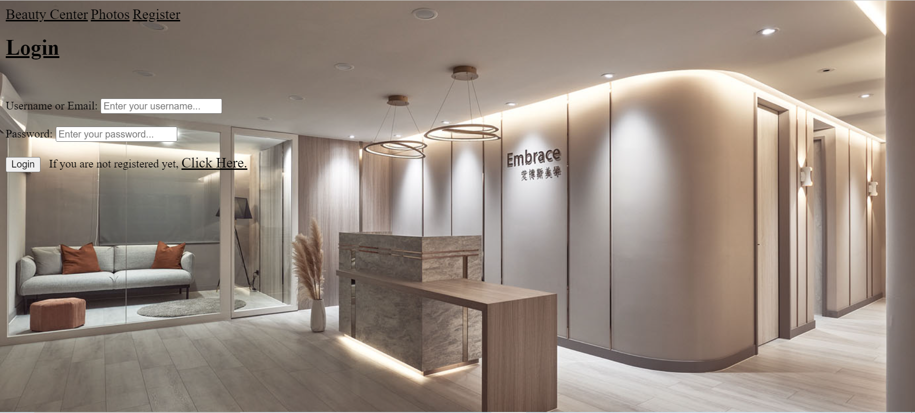

**Client’s Profile**

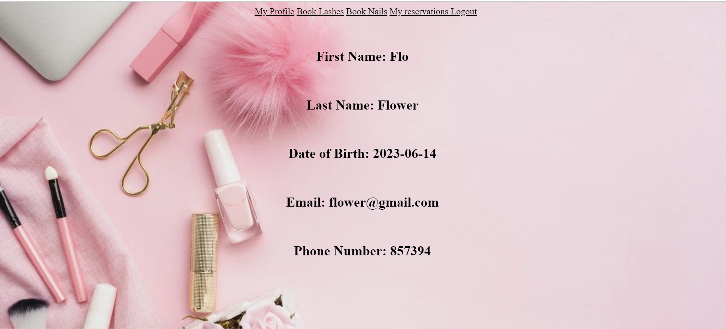

**Book Lashes**

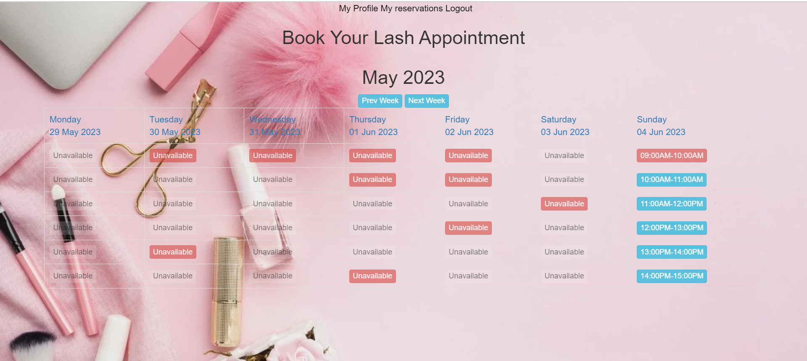

**Reservations of client**

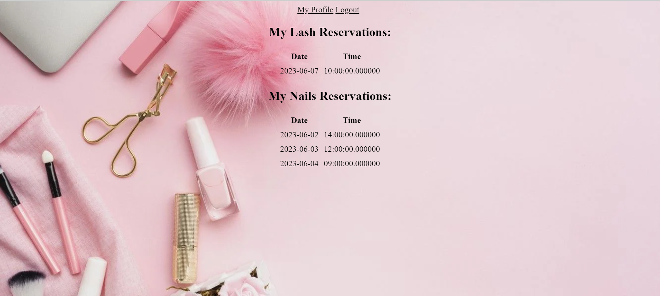

**Technician’s Profile**

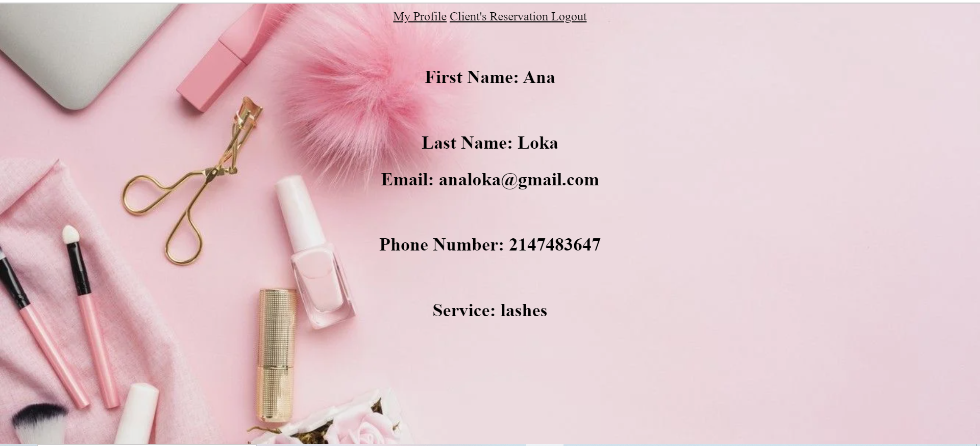

**Client’s Reservation in technician’s account**

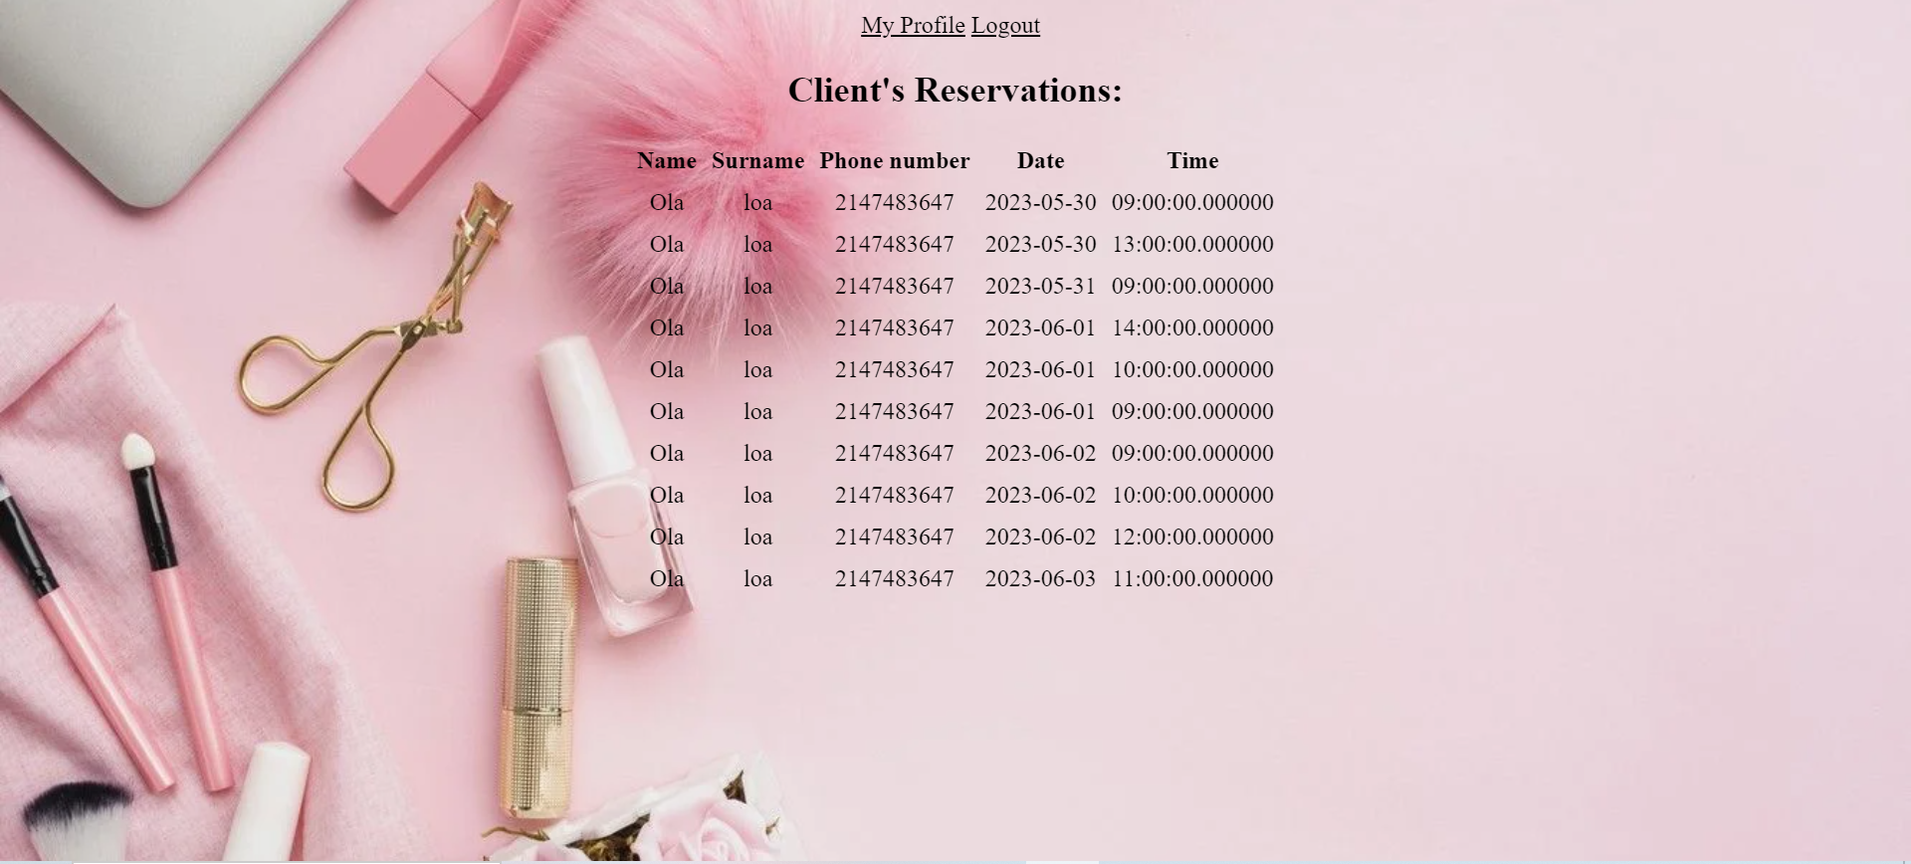

**Database:**

In MySQL, we have created a database consisting of 4 tables: users, employee, book and booknails.

Users table is used to store the information of the clients when they get registered, get their information in order to login, and get their information to display in the profile.

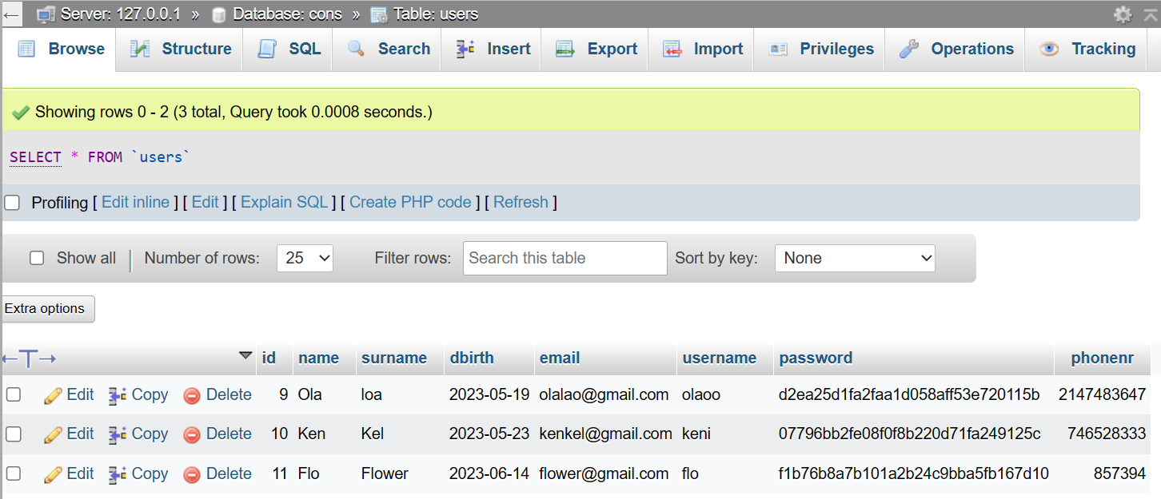

Employee table is used to store the information of the nails and lashes technicians and get their information to display in the profile.

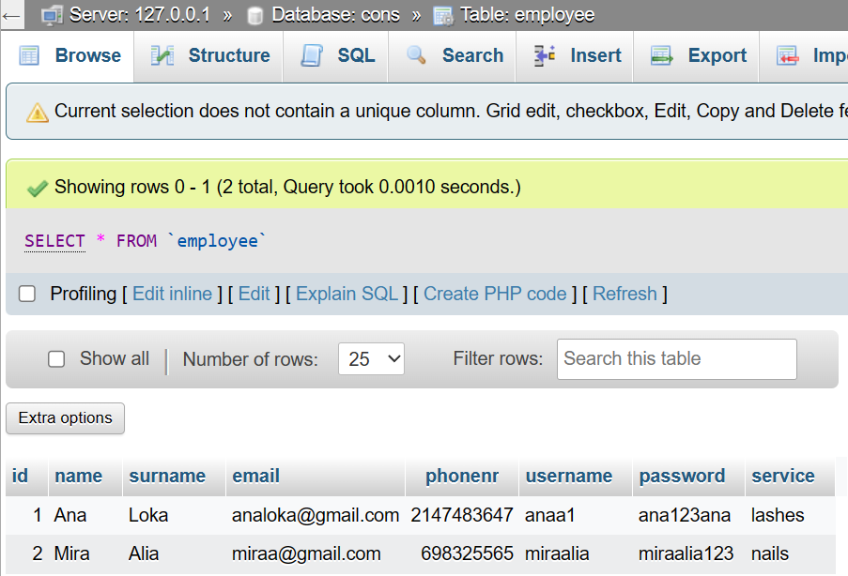

Book table is used to store those clients' information who book appointments for lashes.

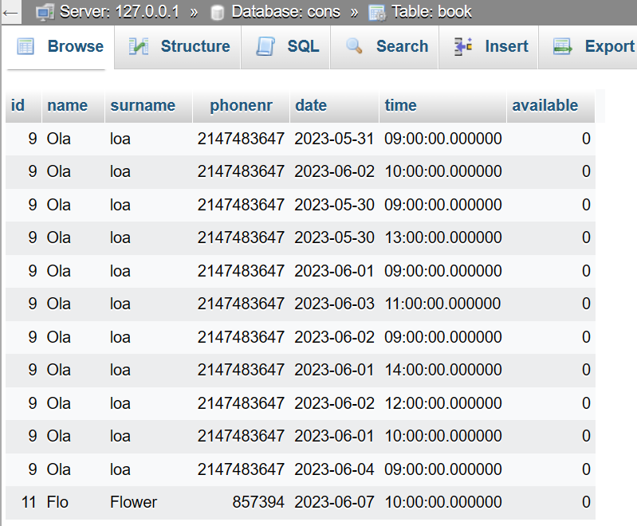

Booknails table is used to store those clients’ information who book nails appointments.

